
Cottage 6 – Sponsor emails and orphan photos
Daveline Okwayo and Cate Rajwayi
# | First Name | Last Name | Sponsor | Photo August 2026 | Photo
1 | Marrianna  Female | Natelo | Marshal, Yanica  yanicamars@yahoo.com  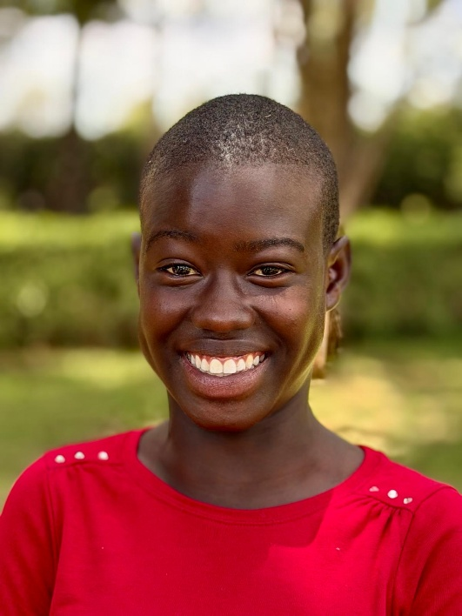 | 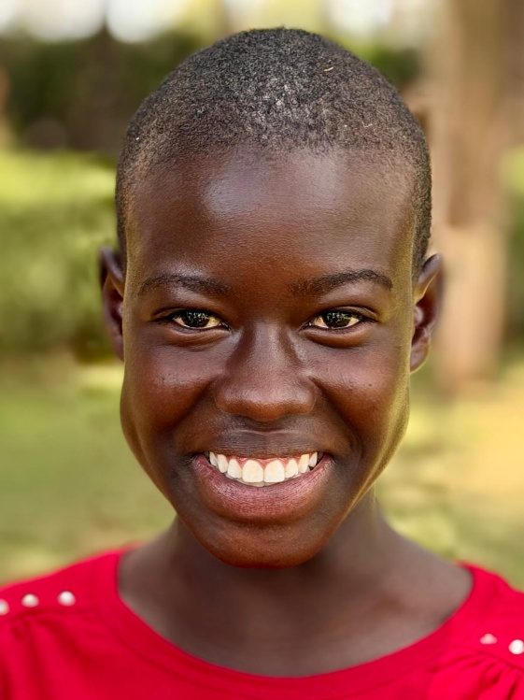 | 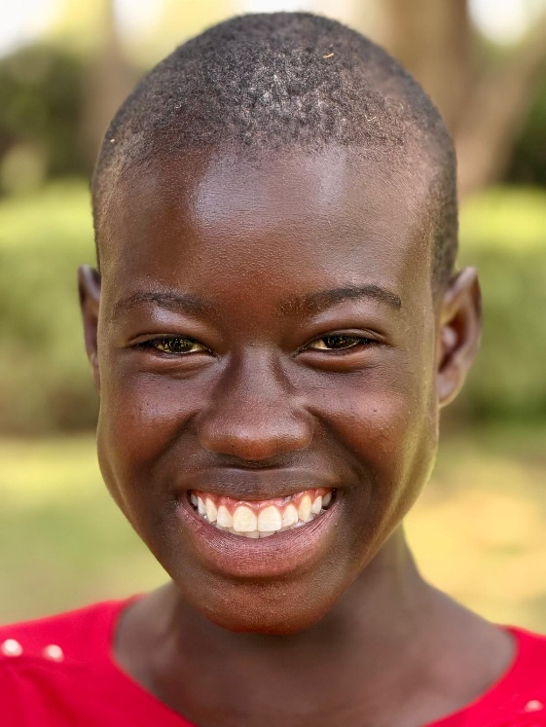
2 | Judith Nakeir  Female | Namlele | Stewart, Dana & Dawn  samwise0351@gmail.com  dawns.3107@gmail.com | 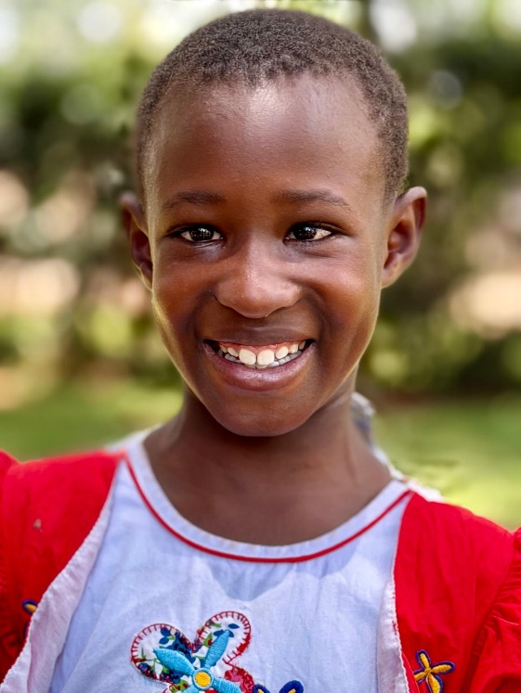 | 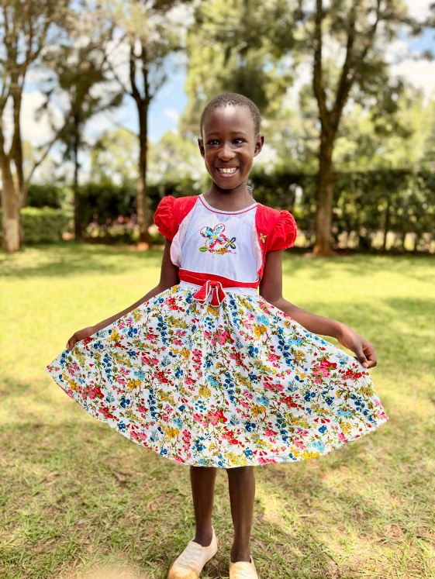
3 | Rebecca  Female | Chelele | Reed, Jack & Catherine | 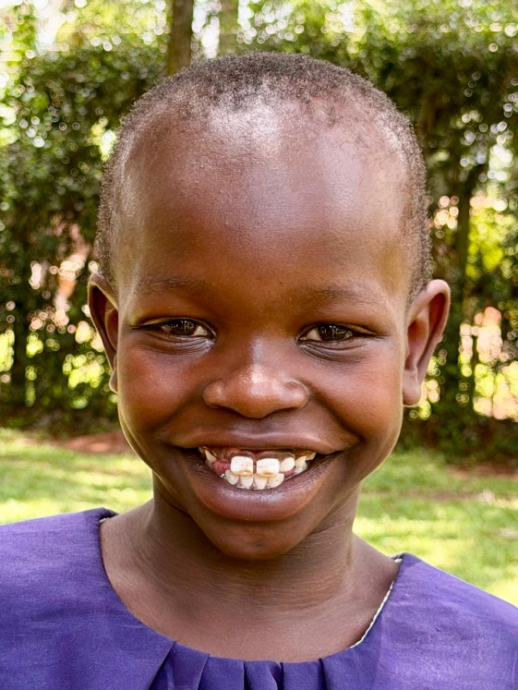 | 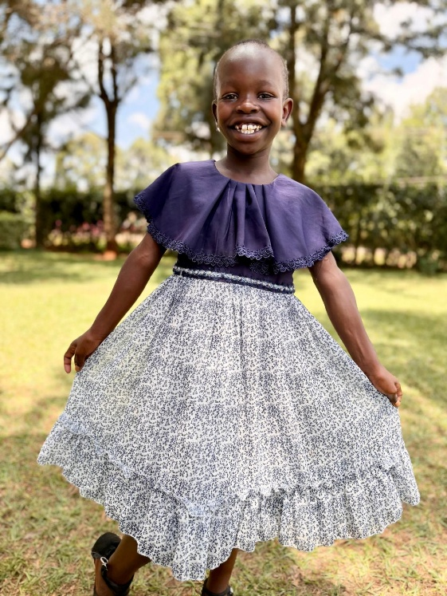
4 | Sharon  Female | Nakoth | Patrick, Luke & Kate  lukewpatrick@gmail.com  katemustdecrease@gmail.com | 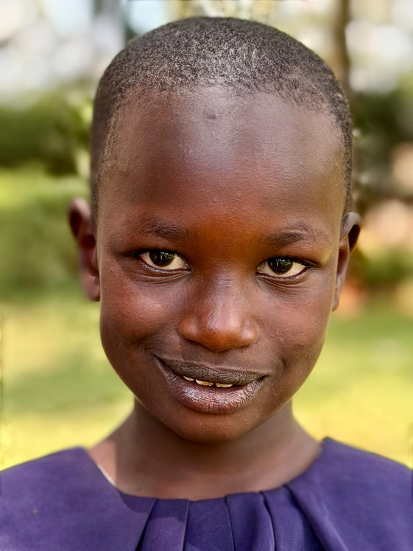 | 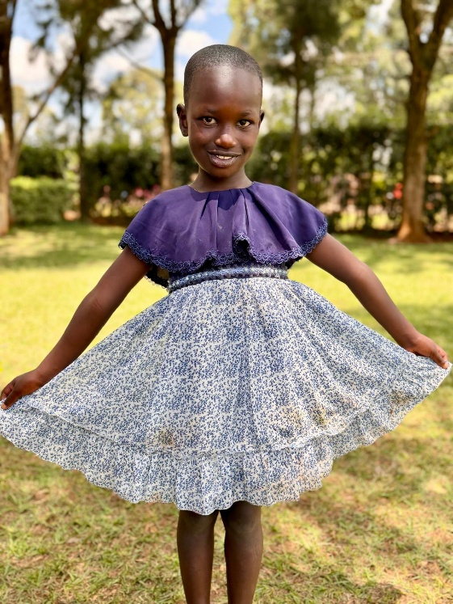
5 | Esther  Female | Kamonya | Lange, John & Vicki  bjlangeiii@comcast.net  vvlange@comcast.net | 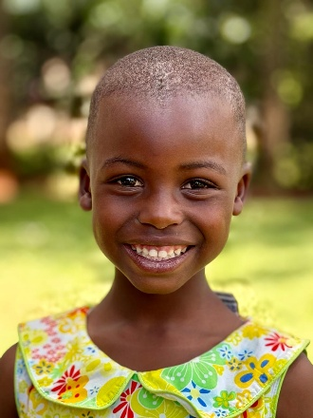 | 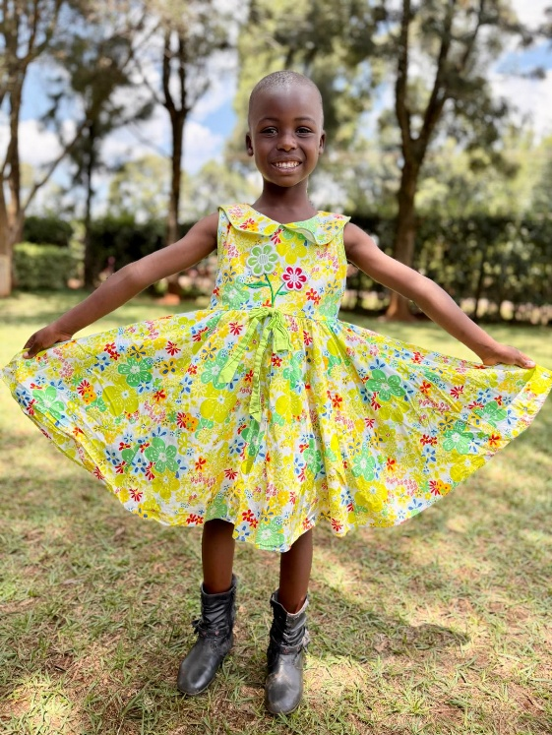
6 | Mary  Female | Valentine | Wiens, Steve & Mary  wiens.steven@gmail.com  speedywiens@gmail.com | 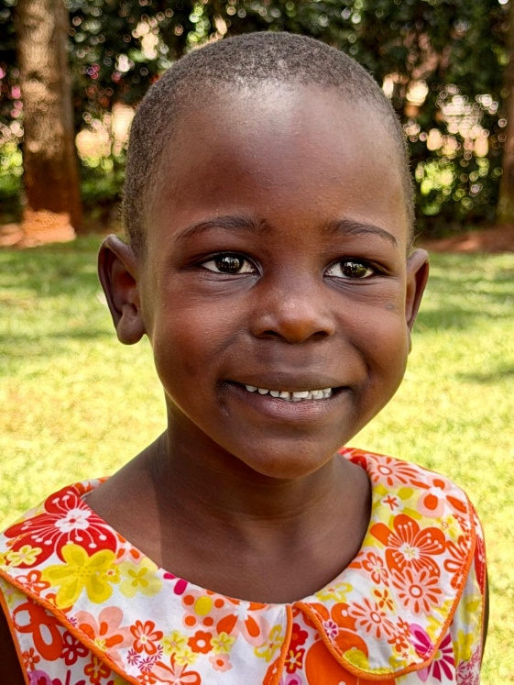 | 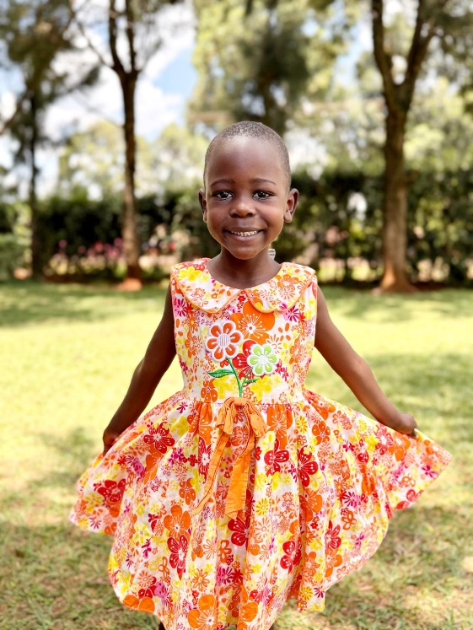
7 | Douglas | Ombuge | Greene, Aaron & Stephanie  iceman20tx@yahoo.com  stephanieandaaron@yahoo.com | 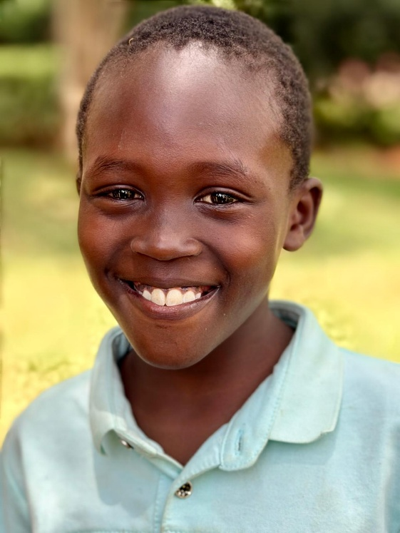
8 | Joel | Emuria | Moore, Mike & Jenny  mikemoore805@gmail.com  mikeandjenny1@sbcglobal.net | 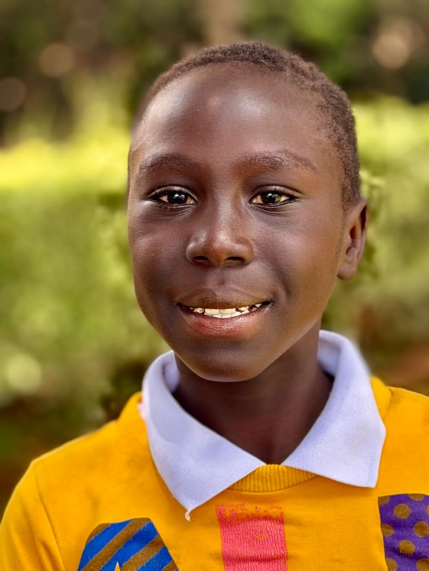
9 | Andrew Shioto | Muchina | Reed, Jack & Catherine  Jhreed40@gmail.com  Cmreed24@gmail.com | 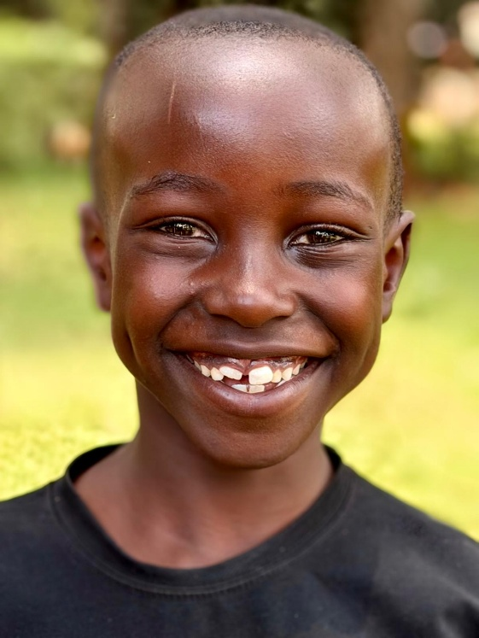
10 | Jayden Chitechi | Macharia | Pizzini, Mina  mina.pizzini@gmail.com | 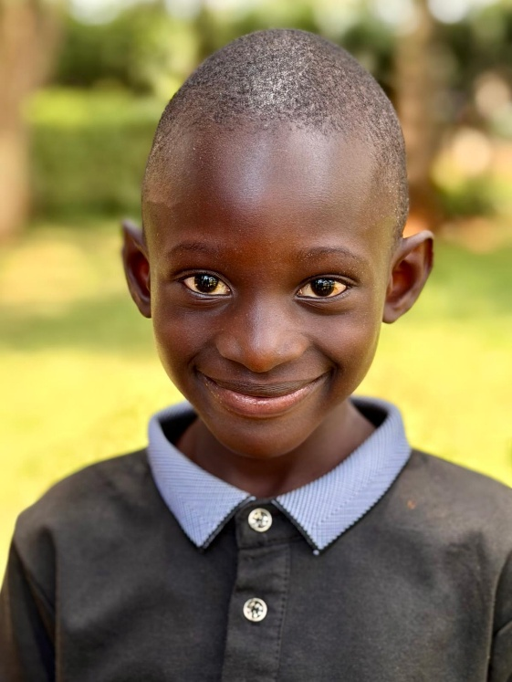
11 | Lavich Rashid | Etapar | Lamb, Michael & Michele Alexander  43rdrunner@gmail.com  michelealexander@gmail.com | 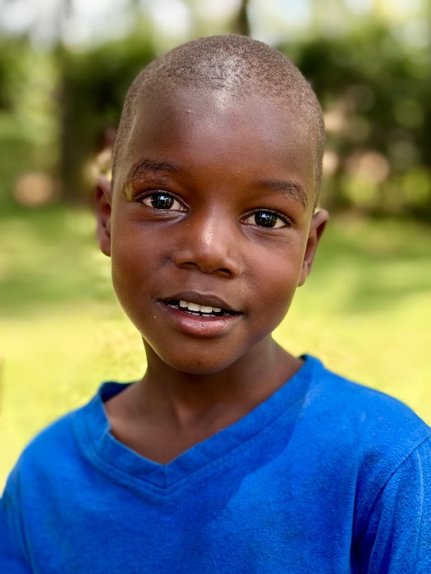
12 | Jayden | Bahati | Bohn, Mickey & Emily  mickey.bohn@gmail.com  emilybohn25@gmail.com | 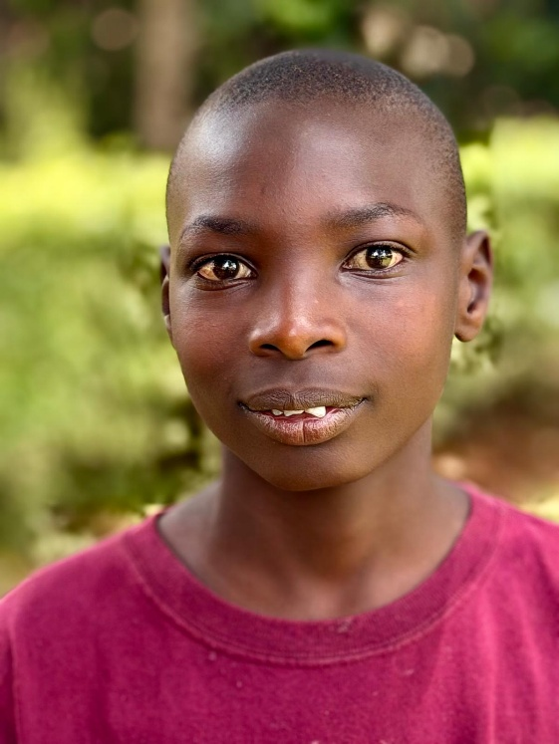
 | FAMILY
14 |  |  |  | 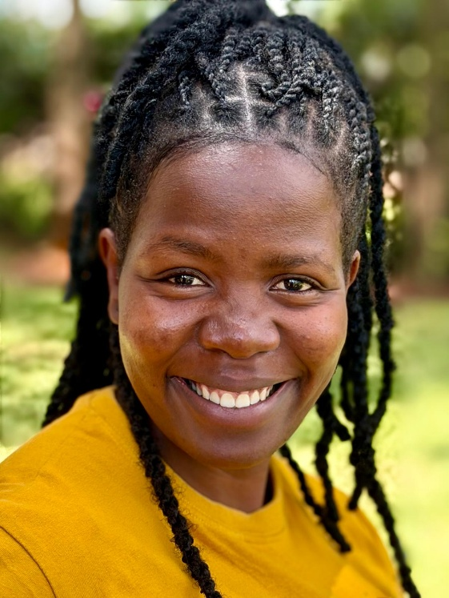 | 